# SSH key generation

You can use SSH keys to establish a secure connection between your computer and Stash for when you are performing Git operations, however the option to clone using SSH only becomes available once you've added an SSH key to your user profile in Stash. Supported key types are DSA and RSA2. RSA1 is not supported.

1. Open **Git Bash** and run the following command:-

**ssh-keygen**

You shall see the following response:-



1. Press <Enter> to accept the default location and file name. If the .ssh directory doesn't exist, the system creates one for you.
2. Enter, and re-enter, a passphrase when prompted [ Passphrase is an optional value which acts as another layer of credentials while you connect to the Git repository]. Please check the link <https://help.github.com/articles/working-with-ssh-key-passphrases/> which discusses about passphrases.

The whole interaction will look similar to this:-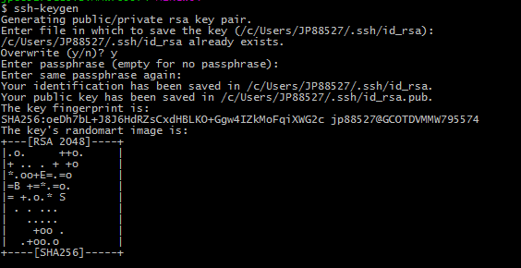

1. You can find your generated key here: **C:/Users/[Your SOEID]/.ssh/id_rsa.pub**
2. Enter **C:/Users/[Your SOEID]/.ssh/id_rsa.pub** to display the public key content.
3. Copy contents of Public key
4. Log in to Bitbucket
   1. Click on "Manage account" from top right corner of GUI)



* 1. Click on "SSH Keys"

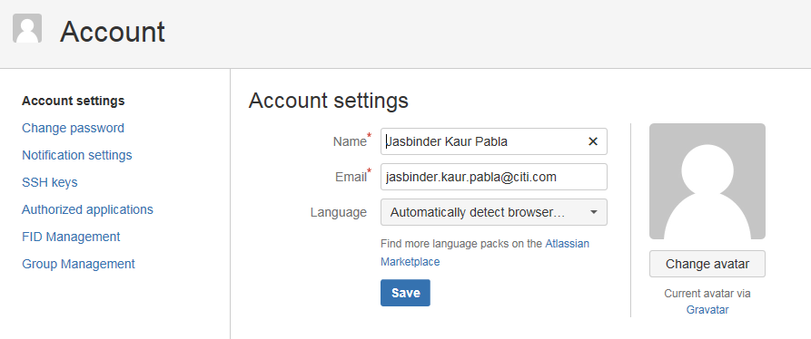

* 1. Click on "Add Key"

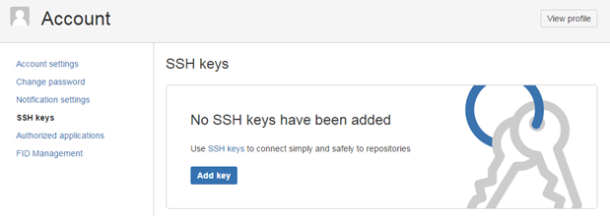

* 1. Paste the complete SSH keys generated from the Step above:-

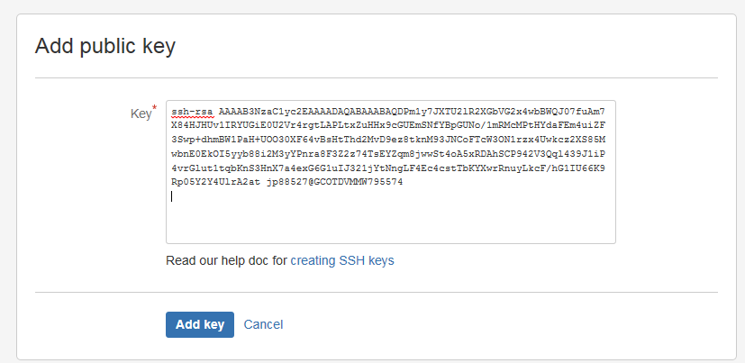

* 1. Click on "Add key", You can see your key is now configured to use (Label - SOE ID@VDI machine name)

